

Project Name
Project Practicum

Submitted By

MAI SOKLYNA

Supervisor
TOUCH NGUONCHHAY

Faculty of Engineering
Royal University of Phnom Penh
Submit Date: 28 January 2026

Acknowledgment
I would like to express my sincere gratitude to all those who have contributed to the successful completion of this Project Practicum.
First and foremost, I would like to thank my supervisor, Mr. TOUCH NGUONCHHAY, for his valuable guidance, continuous support, and constructive feedback throughout the development of this project. His expertise, encouragement, and patience played an essential role in helping me complete this practicum successfully.
I also extend my sincere appreciation to the Faculty of Engineering, Royal University of Phnom Penh, for providing the academic environment, facilities, and resources necessary for carrying out this project.
Furthermore, I would like to thank my peers and classmates for their cooperation, ideas, and moral support during the project period. Finally, I am deeply grateful to my family for their constant encouragement, understanding, and support throughout my studies.
This project would not have been possible without the support and contributions of all those mentioned above.

Table of Contents

Acknowledgment
Table of Contents
1. Introduction page 5
2. Project Review page 7
3. Methodology page 9
4. Project Design page 15
5. Implementation page 31
6. Testing page 37
7. Future Work page 41
8. Conclusion page 41
9. References page 41

List of Figures
Figure 1 - methodology
Figure 2 - system design phase
Figure 3- timeline phase
Figure 4- Use Case Diagram - Customer (Shopper) Merchant and Admin Activities
Figure 5- Database Design - Users & profile Relationships
Figure 3- Database Design - Users Relationships
Figure 4 - Database Design - Products Relationships
Figure 5 - Database Design - Orders and Order Items Relationships
Figure 6- Database Design - Merchant Relationships
Figure 7- Database Design - Product Catalog Relationships
Figure 8 - Database Design - Shopping Cart Relationships
Figure 9 - Database Design - Order & Order Items Relationships
Figure 10 - Database Design - Reviews & Verification Relationships
Figure 11 - Database Design - Invoices & Support Relationships
Figure 12 - Database Design - Payment Table Relationships
Figure 13- UX/UI Design -User
Figure 14- UX/UI Design -Admin
Figure 15- UX/UI Design -Customer-Journey
Figure 16- Backend & frontend integration with Technology Stack
Figure 17- Webhook-based System Architecture with Technology Stack.
Figure 18- testing tools

1. Introduction
Mini Ecommerce Telegram Bot is a mobile-first e-commerce platform that enables Cambodian merchants to sell directly to customers through Telegram, providing a simple and cost-free channel for online selling.

1.1 Problem Description and Statement
Problem Description
Small shop owners in Cambodia struggle to expand online because existing solutions (FoodPanda, E-Get, Grab) charge prohibitive commissions (20-30%) [6] and are designed for restaurants/large businesses. Currently, merchants manage sales through one-to-one Telegram chats, which is disorganized and inefficient. Customers have no centralized place to discover, compare, or purchase from multiple merchants, and everything from order tracking to payment is handled manually through messages.
Core Pain Points:
- No affordable online presence
- Order management is chaotic (messages get lost)
- Scattered customer data with no backup
- No integrated payment system
- Customers can't track orders or find shop locations
- Customers must message multiple merchants individually to compare

Problem Statement
Although many small merchants in Cambodia want to expand their business online, they cannot afford expensive app-based solutions like FoodPanda or E-get which charge 20-30% commission and require difficult onboarding. Currently, merchants use Telegram to chat with customers individually, but this is not organized and does not create a unified marketplace. Customers do not have a convenient, centralized place where they can discover and purchase products from multiple verified merchants. Therefore, there is a need for a simple online shopping platform built inside Telegram that helps merchants sell their products and helps customers shop easily - without requiring customers to download another app.
The Solution: Build a shopping marketplace inside Telegram (not a separate app) because:
- Merchants already use Telegram to reach customers
- Customers already use Telegram daily (so no need to download another app)
- It provides an affordable, organized alternative to expensive delivery apps
- It creates a unified space where customers can discover, browse, and purchase from multiple verified merchants while merchants can manage orders, payments, and customer data efficiently
The key insight is leveraging Telegram's existing popularity in Cambodia rather than asking users to adopt a new platform.

1.2 Objectives
The main objectives of this project are:
Primary Objectives
- Create a Telegram Bot Shopping Interface - Develop a Telegram bot that allows customers to browse products and place orders directly through Telegram without needing to download a separate app.
- Enable Product Management - Provide merchants with an easy way to add, edit, and remove their products without needing technical knowledge. Merchants should be able to manage through a web dashboard.
- Implement Order Management System - Create a system where merchants can receive orders, confirm them, and manage delivery status.
- Support Multiple Merchants - Design a system where multiple merchants can sell their products to the same group of customers on the same platform.
- Implement Shopping Cart Functionality - Allow customers to add multiple products to a cart from different merchants and checkout together.
- Enable Order Tracking - Provide customers with ability to see order status and delivery updates in real-time through Telegram.
- Implement Secure Authentication - Ensure that merchants and customers have secure login with proper credentials (JWT tokens).
- Support Multiple Payment Methods - Support both KHQR payment (popular in Cambodia but not yet to integrate it) and Pay on Delivery payment methods so customers can choose their preferred payment option.
- Create Admin Dashboard - Develop a web dashboard where merchants can manage their products, view orders, and track sales.
- Implement Customer Support System - Provide a way for customers to contact merchants with questions or issues directly through the platform.
Secondary Objectives
- Create a responsive web dashboard for merchants to view their sales
- Implement notification system to inform merchants of new orders
- Design a user-friendly interface suitable for Cambodian users
- Ensure the system works properly on mobile phones
- Test all features to ensure they work correctly

2. Project Review

2.1 Existing Project 1 Review
BotStore.cc (botstore.cc)
Full e-commerce bot platform for Telegram.
Features:
- Catalog and cart functionality
- Payment and CRM features
- Analytics and promo codes
- Multilingual support
Limitations for Cambodia:
- Payments non-local - Providers not Cambodia-specific on their pricing page
- Single merchant - Each merchant operates separately
- No multi-merchant marketplace - Doesn't solve customer discovery
- Generic global solution
- Not optimized for Cambodia's payment ecosystem
[botstore.cc]

2.2 Existing Project Review
2 Teleport (teleportapp.store)
Telegram Mini-App store builder with product modifiers.
Features:
- Modifiers for product options (clothing size, etc.)
- Full shopping cart system
- Supports Cash on Delivery / pickup methods
Limitations for Cambodia:
- No Cambodia payment gateway - Uses generic Telegram payments + third-party providers
- No KHQR or ABA - Not local-payment optimized
- Single merchant focused - Each merchant is separate shop
- No multi-merchant marketplace - Doesn't solve customer discovery problem
- Primarily for global market
[teleportapp.store]

2.3 Project Review Current Practice in Cambodia
Telegram Channels + Manual DM Ordering
Many small merchants in Cambodia currently use Telegram to chat directly with customers one-by-one.
How It Currently Works:
- Merchants create Telegram channel or group
- Post product photos and price lists
- Customers DM merchant with order details
- Merchant and customer negotiate manually
- No organized product listing
- No cart system
- Payment arranged directly (cash, mobile money)
Strengths:
- Free to use
- Directly in Telegram (customers already have app)
- Works for any product type
- Merchants can share location in Telegram
- Direct merchant-customer relationship
Limitations:
- No product variants - Can't show sizes, colors, options
- No cart system - Customer orders one item at a time
- No order management - Orders tracked only in manual chat history
- No payment processing - Manual payment negotiation
- No order tracking - Customer has no way to track status
- No centralized marketplace - Each merchant isolated
- Very inefficient - Merchants spend hours on manual DMs
- Looks unprofessional compared to real shops
- Data loss risk - If merchant changes phone, all data lost

3. Methodology
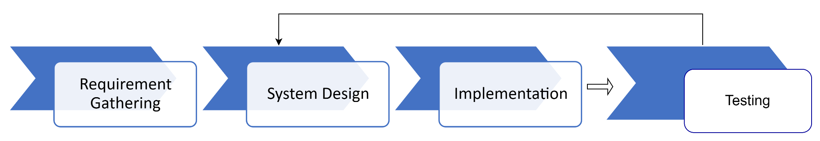
Figure 1 -methodology
The development of this project follows the following steps:

3.1 Requirement Gathering Phase
This phase identifies what the system must do and what users need. It ensures the project focuses on the most important features (Telegram selling flow + merchant dashboard) and avoids building unnecessary functions. This phase is important because clear requirements reduce future changes and confusion.

3.2 System Design Phased
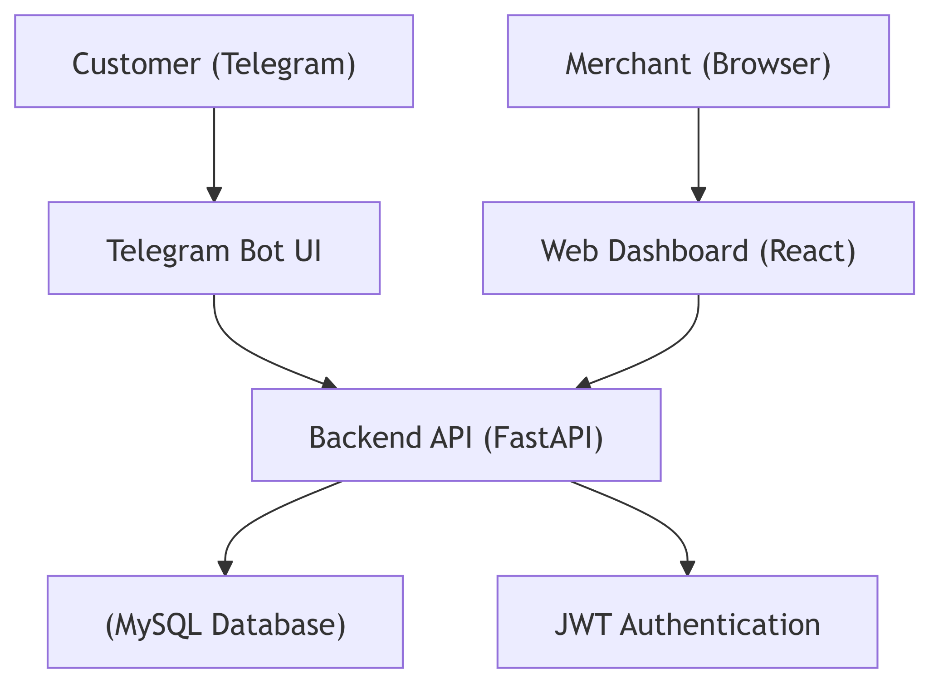

Figure 2 -system design phase
This phase explains how the system will work before coding starts. It defines the overall structure, such as how the Telegram bot and web dashboard communicate with the backend server and database. A good design helps the system stay organized, scalable, and easier to implement.

3.3 TimeLine Phase
This phase is where the system is developed and integrated based on the design. Backend, database, Telegram bot, and web dashboard are built step-by-step until they work together as one complete system. This phase takes the longest time in the 15-week schedule because it involves most of the programming work.

3.4 Testing PhaseTested all Telegram bot commands
This phase checks whether the system works correctly and meets the requirements. It ensures the Telegram bot, web dashboard, APIs, and database behave as expected and that errors are fixed. Testing may require returning to design or implementation to improve the system and remove bugs.
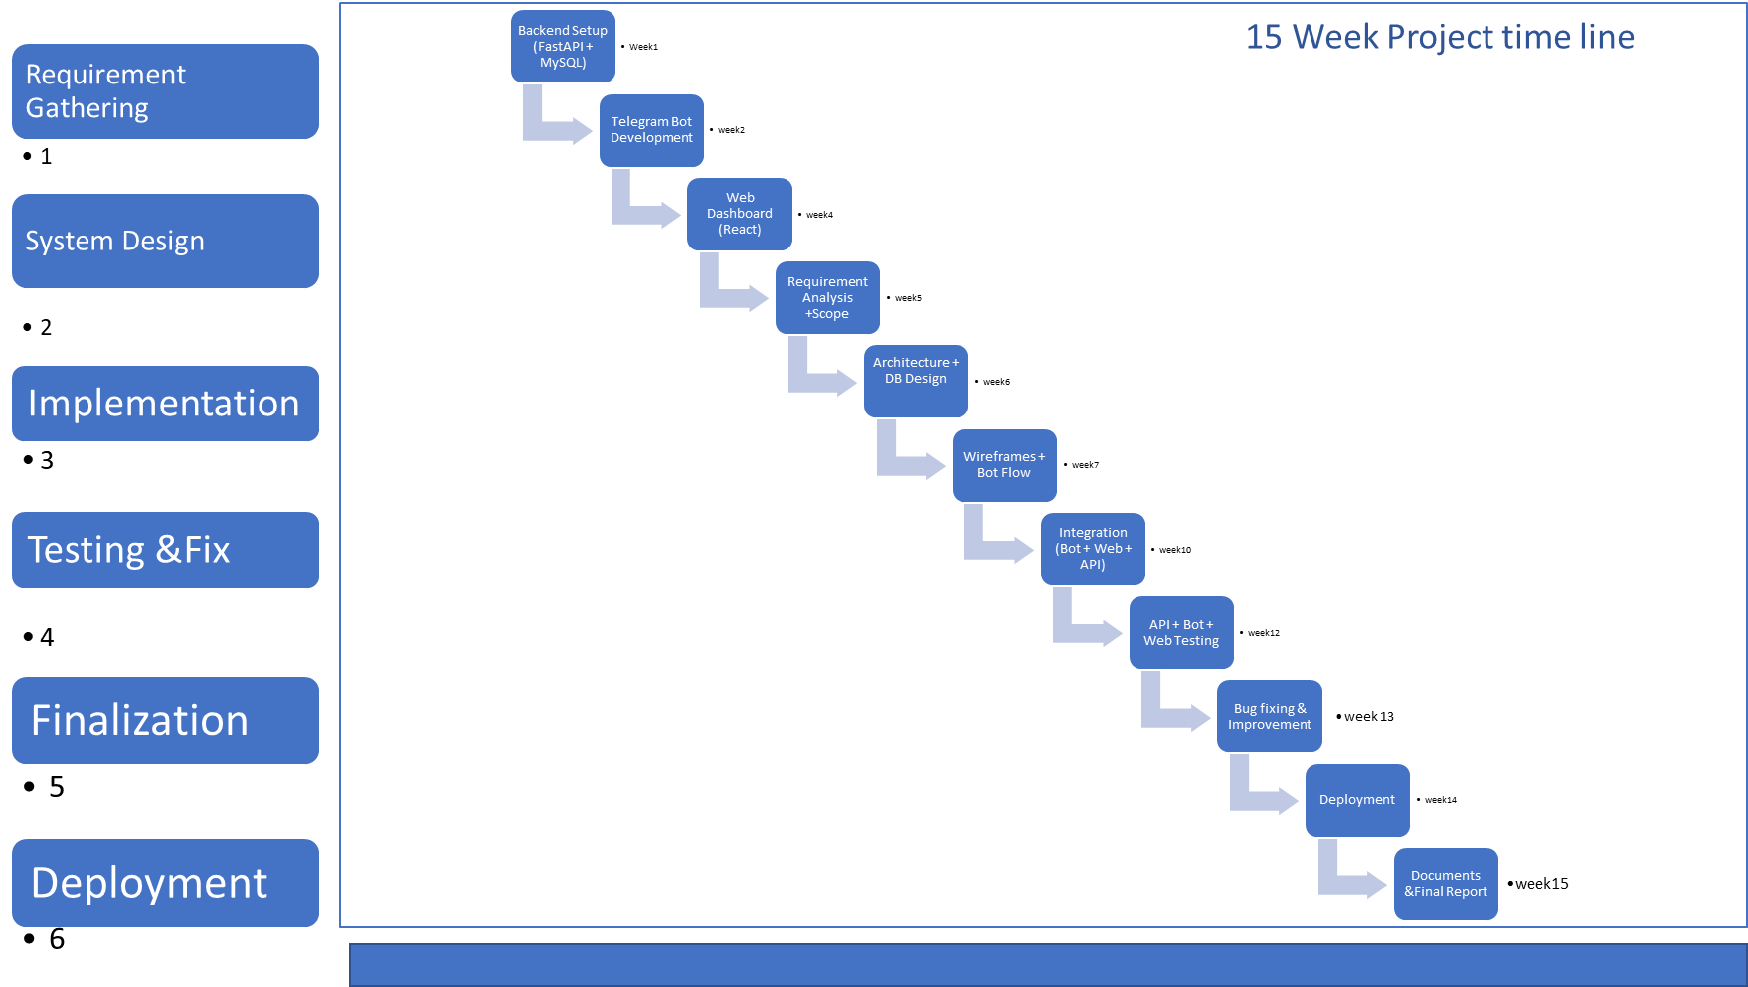

Figure 3 -timeline phase
Detailed Explanation of Each Step (Final 15‑Week Timeline)
1. Requirement Analysis + Scope
This step defines the foundation of the project.
Activities include:
- Collecting problems faced by Cambodian merchants and customers when selling on Telegram.
- Defining core features such as product browsing, cart, checkout, merchant dashboard, and KHQR/COD payment flow.
- Identifying all actors (Customer, Merchant Admin, Super Admin).
- Deciding what is in scope (Telegram marketplace + dashboard) and out of scope (mobile apps, shipping automation, payment gateway integration beyond KHQR mock).
Outcome:
A clear requirement document guiding the entire project.

2. Architecture + Database Design
This step shapes how the system works behind the scenes.
Activities:
- Designing the system architecture for a multi‑component solution:
Telegram Bot ↔ FastAPI Backend ↔ MySQL Database ↔ Next.js Dashboard.
- Creating ERD diagrams for Users, Merchants, Products, Orders, Payments, Reviews, Support Tickets, Telegram Configs.
- Planning API endpoints (auth, products, orders, cart, reviews).
Outcome:
A complete technical blueprint ensuring the system is scalable, secure, and modular.

3. Wireframes + Bot Flow
This step focuses on user experience and interaction.
Activities:
- Creating Telegram bot flow charts (product browsing, cart, checkout, order tracking).
- Designing UI wireframes for the merchant dashboard (product management, order views, analytics).
- Planning the logical sequence of conversation states in the bot.
Outcome:
A user‑centric flow that ensures consistency across bot and dashboard interfaces.

4. Backend Setup (FastAPI + MySQL)
This step implements the core backend and database.
Activities:
- Setting up FastAPI project structure.
- Implementing user authentication (JWT + Telegram Login URL verification).
- Creating models, schemas, and controllers for products, carts, orders, reviews.
- Setting up MySQL tables with foreign‑key relationships.
- Connecting backend to database securely and testing with Swagger UI.
Outcome:
A working backend foundation ready to integrate with bot and dashboard.

5. Telegram Bot Development
This step builds the customer-facing shopping experience on Telegram.
Activities:
- Implementing bot commands: /start, /shop, /cart, /checkout, /orders.
- Connecting bot messages and buttons to backend API.
- Building product browsing, cart updating, checkout workflow.
- Adding order status tracking and merchant notifications.
- Securing identity using Telegram’s from.id and Login URL authorization.
Outcome:
A fully interactive shopping bot inside Telegram.

6. Web Dashboard (React / Next.js)
This step creates the merchant/admin dashboard.
Activities:
- Implementing merchant login using Telegram Login URL.
- Building pages for product CRUD (Add, Edit, Delete).
- Creating order management pages (view new orders, update status).
- Implementing real‑time merchant notifications.
- Creating analytics sections (sales overview, product performance).
Outcome:
A functional dashboard enabling merchants to manage their shop easily.

7. Integration (Bot + Web + API)
This step integrates all system components.
Activities:
- Connecting Telegram bot responses to live API responses.
- Linking dashboard functions (product updates/order updates) to database.
- Verifying that changes on dashboard appear correctly in Telegram bot.
- Ensuring consistent logic across all client interfaces.
Outcome:
A unified, seamless system where bot, backend, and dashboard work as one.

8. API + Bot + Web Testing
This step ensures the system works reliably.
Activities:
- Testing all API endpoints with Postman and Swagger UI.
- Testing Telegram bot flows: add to cart, remove items, checkout, track order.
- Testing dashboard operations and ensuring data consistency.
- Testing KHQR mock payment flow and COD instructions.
Outcome:
A validated system with correct functionality before final fixes.

9. Bug Fixing & Improvement
This step resolves errors and improves performance before deployment.
Activities:
- Fixing edge‑case bugs in bot commands.
- Improving API performance and query optimization.
- Refining dashboard UI/UX for clarity and ease of use.
- Polishing buttons, messages, and flow for better user experience.
Outcome:
A smooth, optimized, more stable system ready for deployment.

10. Deployment
This step finalizes and releases the system.
Activities:
- Deploying backend (FastAPI) to a cloud server.
- Deploying Next.js dashboard to hosting service.
- Setting Telegram Webhook with HTTPS-enabled domain.
- Configuring domain + SSL + environment variables.
Outcome:
A live, production-ready system accessible to users.

11. Documentation & Final Report
This step prepares all academic and technical documentation.
Activities:
- Writing final practicum report.
- Documenting system architecture, ERD, user journey, and implementation.
- Preparing screenshots, diagrams, and timeline for submission.
Outcome:
A complete final document ready for advisor submission.

4. Project Design
A mini e-commerce bot is a lightweight shopping system embedded inside a messaging platform (Telegram) that allows customers to browse products, manage a cart, and place orders without installing a separate mobile application. In this project, the mini e-commerce bot acts as the customer-facing interface, while merchants and administrators manage operations through a web dashboard. This design reduces adoption barriers for customers and supports Cambodian small businesses that already communicate with customers through Telegram.
Because the platform is multi-tenant, multiple merchants can sell products under the same system while keeping ownership of their own products and orders. The design separates roles and permissions into three actors—Customer, Merchant Admin, and Super Admin to ensure that each user only accesses features relevant to their responsibilities.

4.1 Use Case Diagram
The use case diagram shows how different users interact with the system. The system has three main actors: Customer, Merchant Admin, and Super Admin.
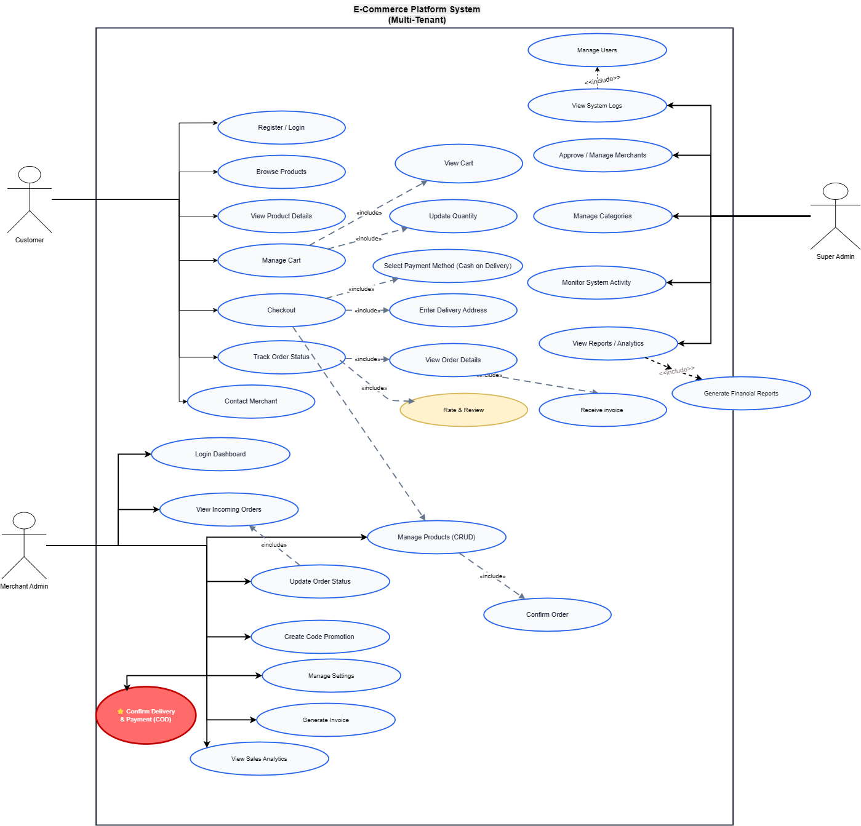
Figure 4: Use Case Diagram - Customer (Shopper) Merchant and Admin Activities
Link https://drive.google.com/file/d/1z74Uay7YjiUt3XBAJ9r_xyhtwttfowCx/view?usp=sharing

Main Actors:
- Customer - Person who browses and buys products
- Merchant Admin - Shop owner who adds products and manages orders
- Super Admin - Person who manages the entire platform
Customer Use Cases:
- Register and login
- Browse product categories and merchants
- View product details with images and reviews
- Add products to shopping cart
- Remove products from cart
- Place order with address and payment method
- View order status and track delivery
- Rate and review products
- Contact merchant with support questions
- View previous order history
Merchant Admin Use Cases:
- Register merchant account with shop details
- Login to merchant web dashboard
- Add new products with descriptions and prices
- Edit product information and availability
- Delete products from catalog
- View list of incoming orders
- Confirm receipt of orders
- Update order status (being prepared, shipped, delivered)
- View sales statistics and revenue
- Respond to customer support tickets
- Generate invoices for orders
- Manage shop settings and promotions
Super Admin Use Cases:
- Manage merchant accounts and approvals
- Monitor all platform orders
- View system logs and activity
- Create promotions and special offers
- Manage product categories
- Generate financial reports
- View platform analytics

4.2 Database Design
The database stores all information needed by the system. The design uses proper relationships and foreign keys to maintain data integrity and support multi-merchant architecture.
1. User & Profile Relationships
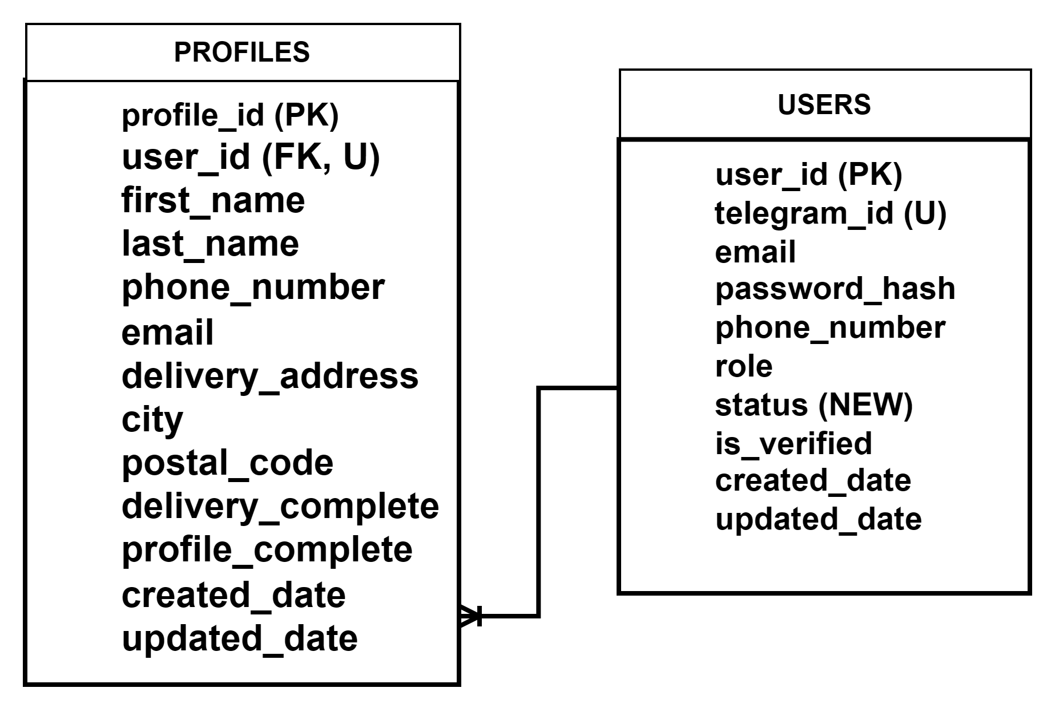
Figure 5: Database Design - Users & profile Relationships
Users ↔ Profiles (1–1): Each user has one profile containing delivery details and personal information.
2 Multi-Tenant (Merchant) Relationships
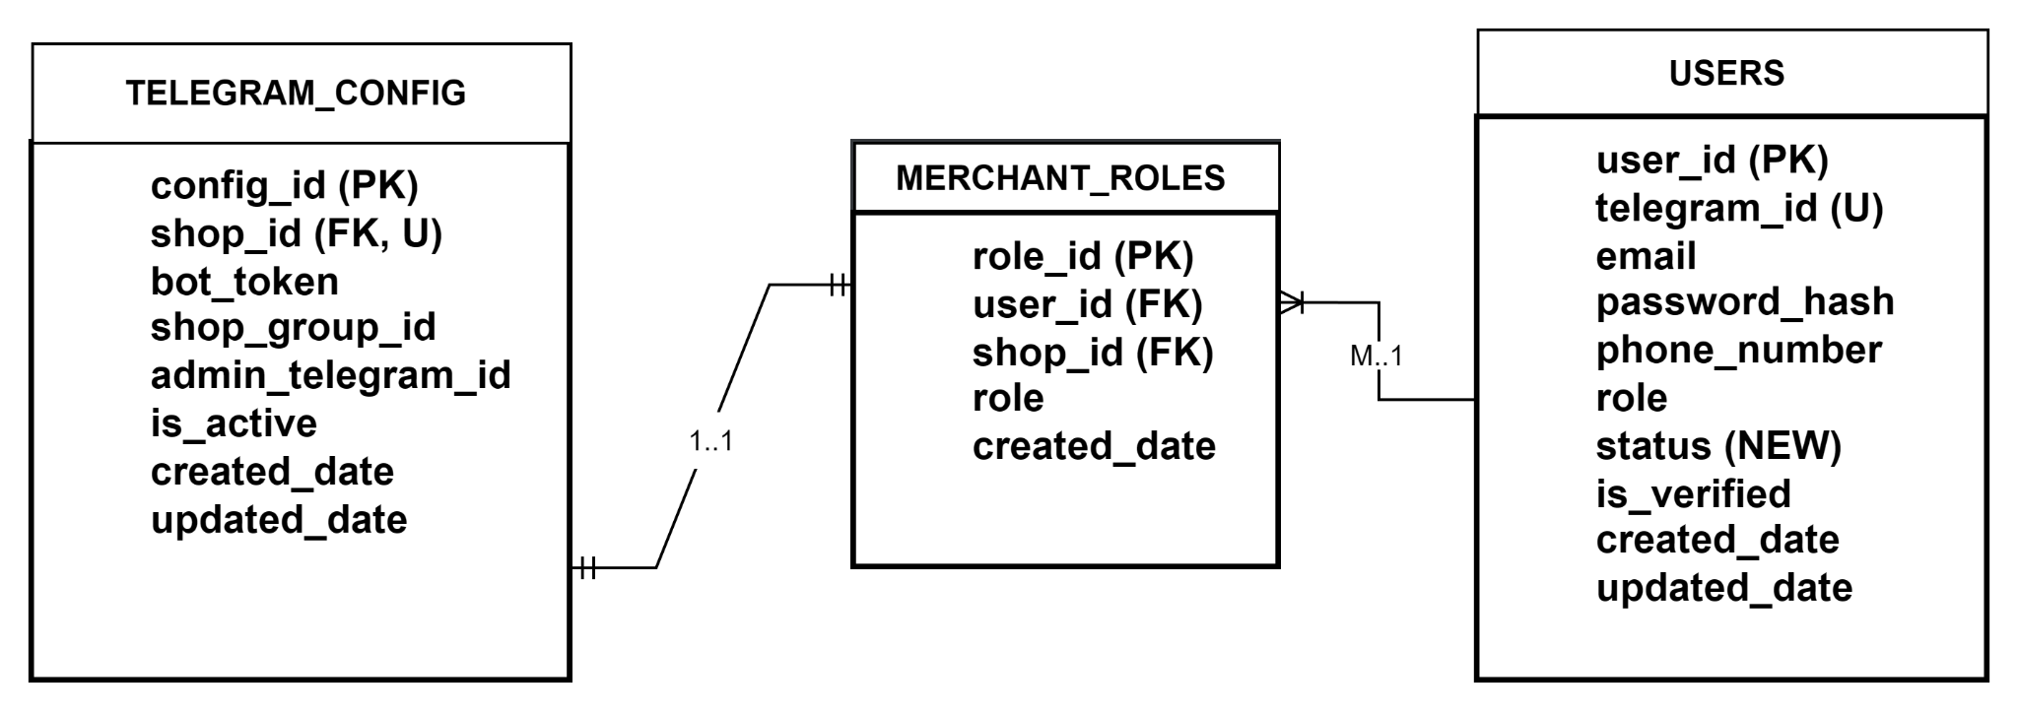
Figure 6: Database Design - Merchant Relationships
Merchants ↔ Telegram Configs (1–1): Each merchant shop can store bot configuration (token/admin id) so the shop can operate inside Telegram.
Users ↔ Merchants (1–M): One user (merchant owner) can create/manage one or more merchant shops. This supports multi-tenant operation.
3. Product Catalog Relationships
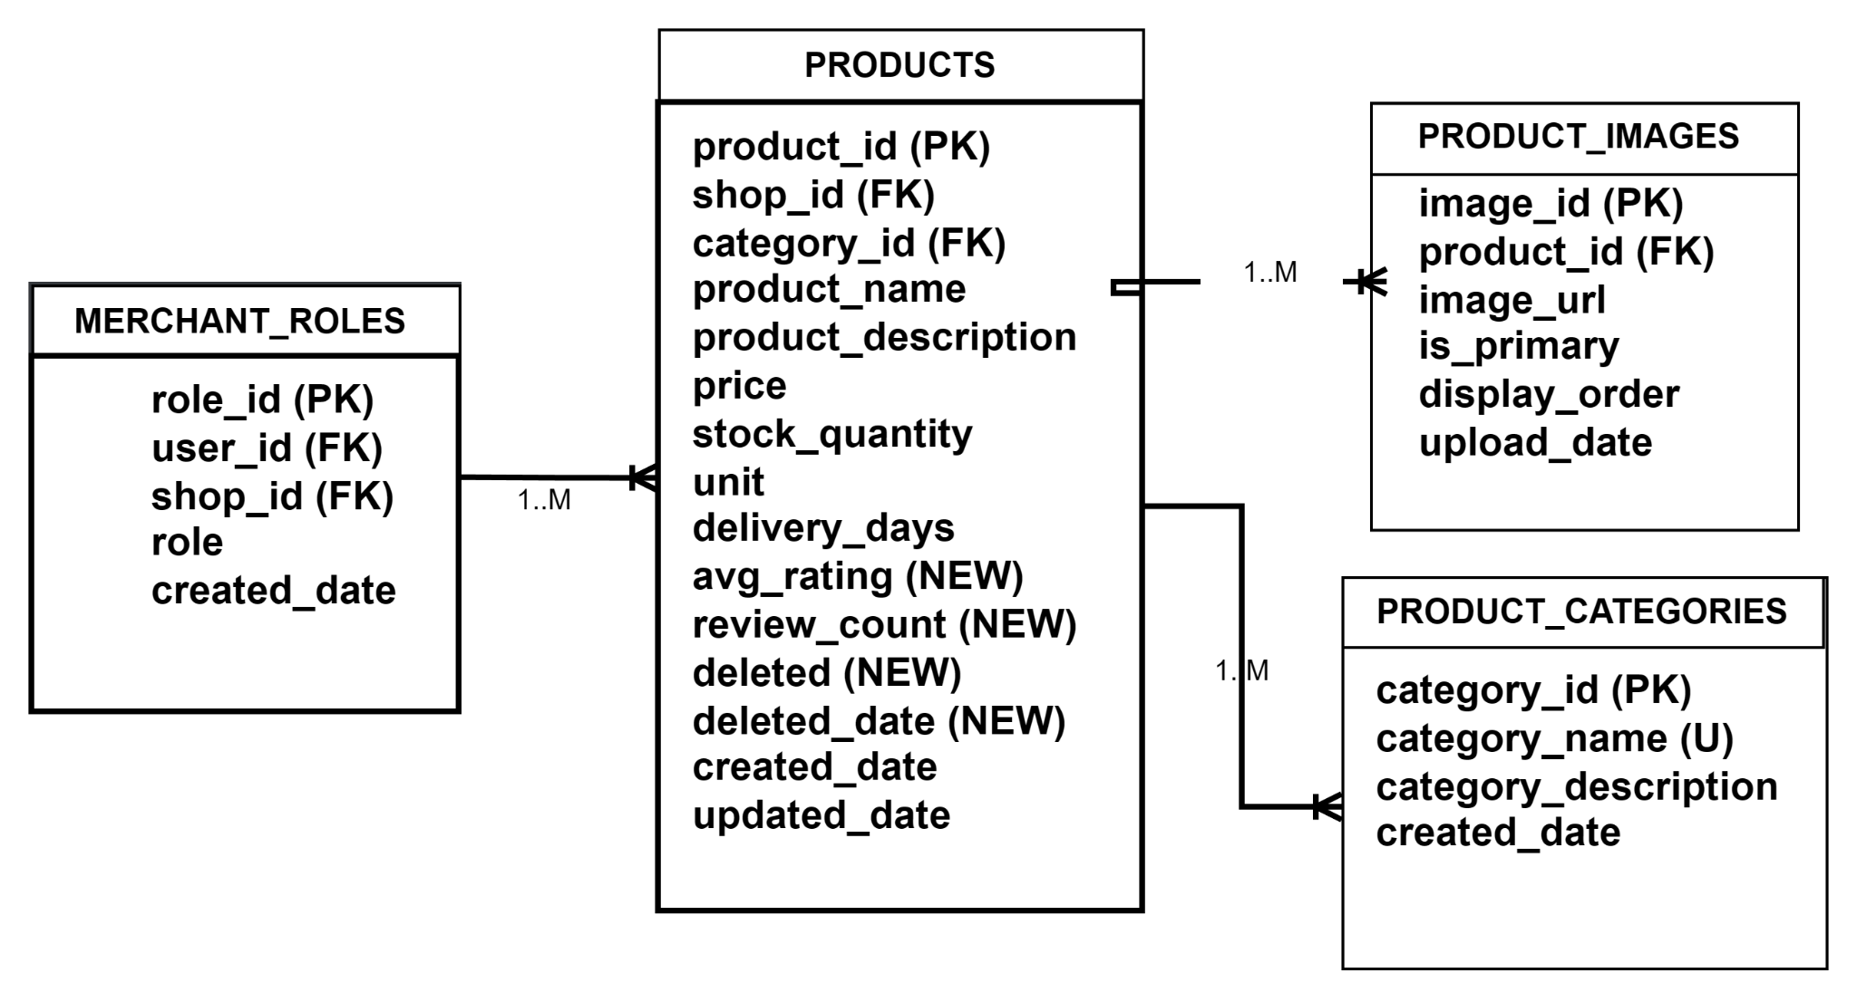
Figure 7: Database Design - Product Catalog Relationships
Products ↔ Product Images (1–M): One product can have many images for better presentation.
Product Categories ↔ Products (1–M): Each product belongs to one category, and a category can contain many products.
Merchants ↔ Products (1–M): A merchant can list many products, but each product belongs to one merchant.

4. Shopping Cart Relationships
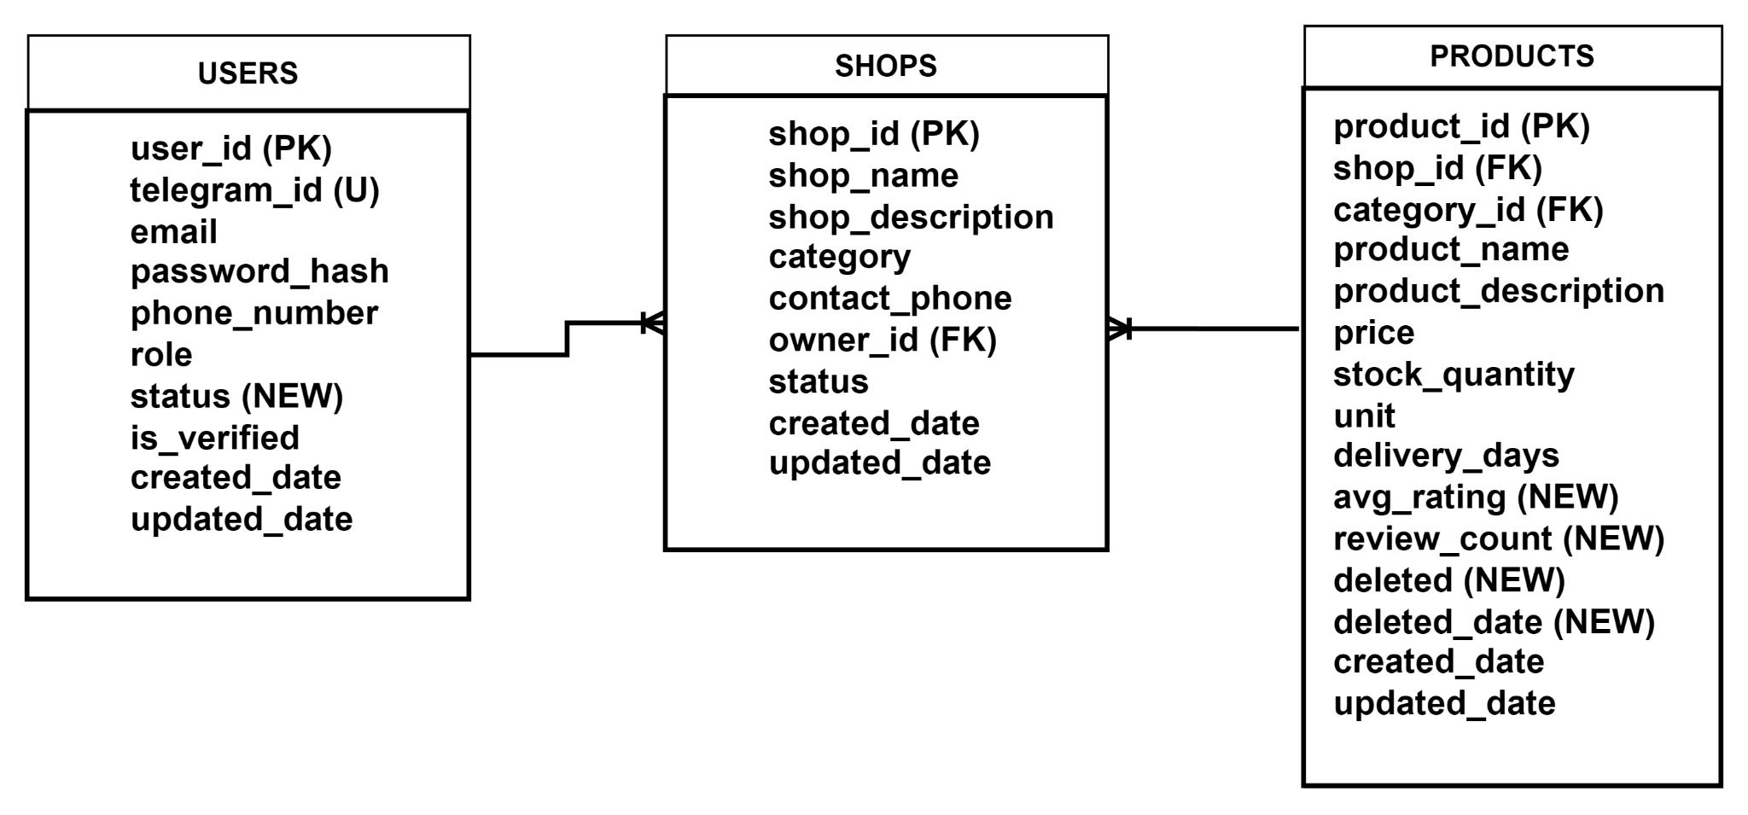
Figure 8: Database Design - Shopping Cart Relationships
Products ↔ Shopping Cart (1–M): A product can appear in many users’ carts.
Users ↔ Shopping Cart (1–M): A customer can have many cart items
5. Orders & Order Items Relationships
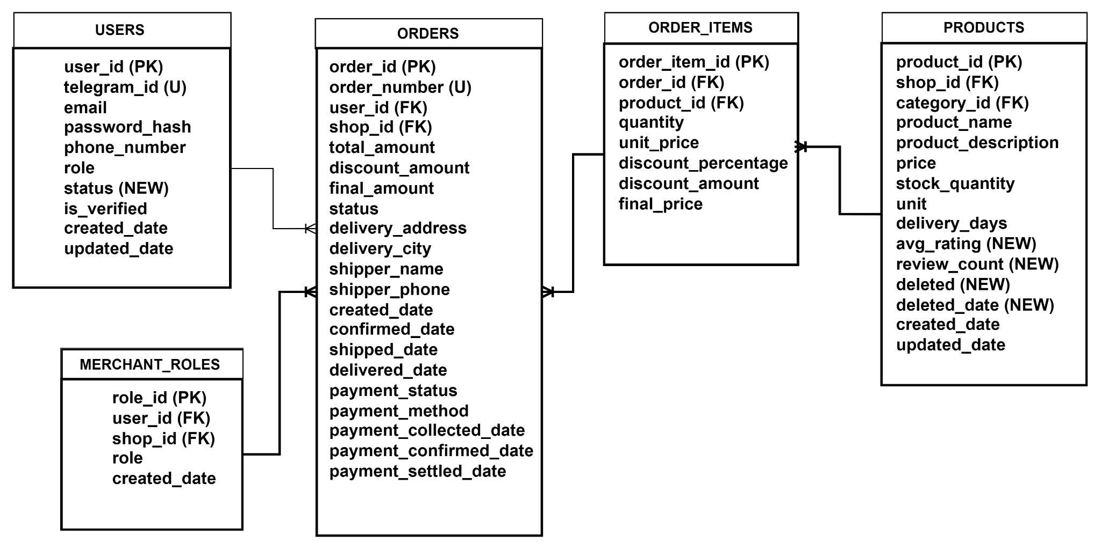
Figure 9: Database Design - Order & Order Items Relationships
Users ↔ Orders (1–M): One customer can place many orders
Products ↔ Order Items (1–M): One product can appear in many order items across different orders
Orders ↔ Order Items (1–M): Each order contains multiple items, stored in Order Items table.
Merchants ↔ Orders (1–M): One merchant can receive many orders.
6. Reviews & Verification Relationships
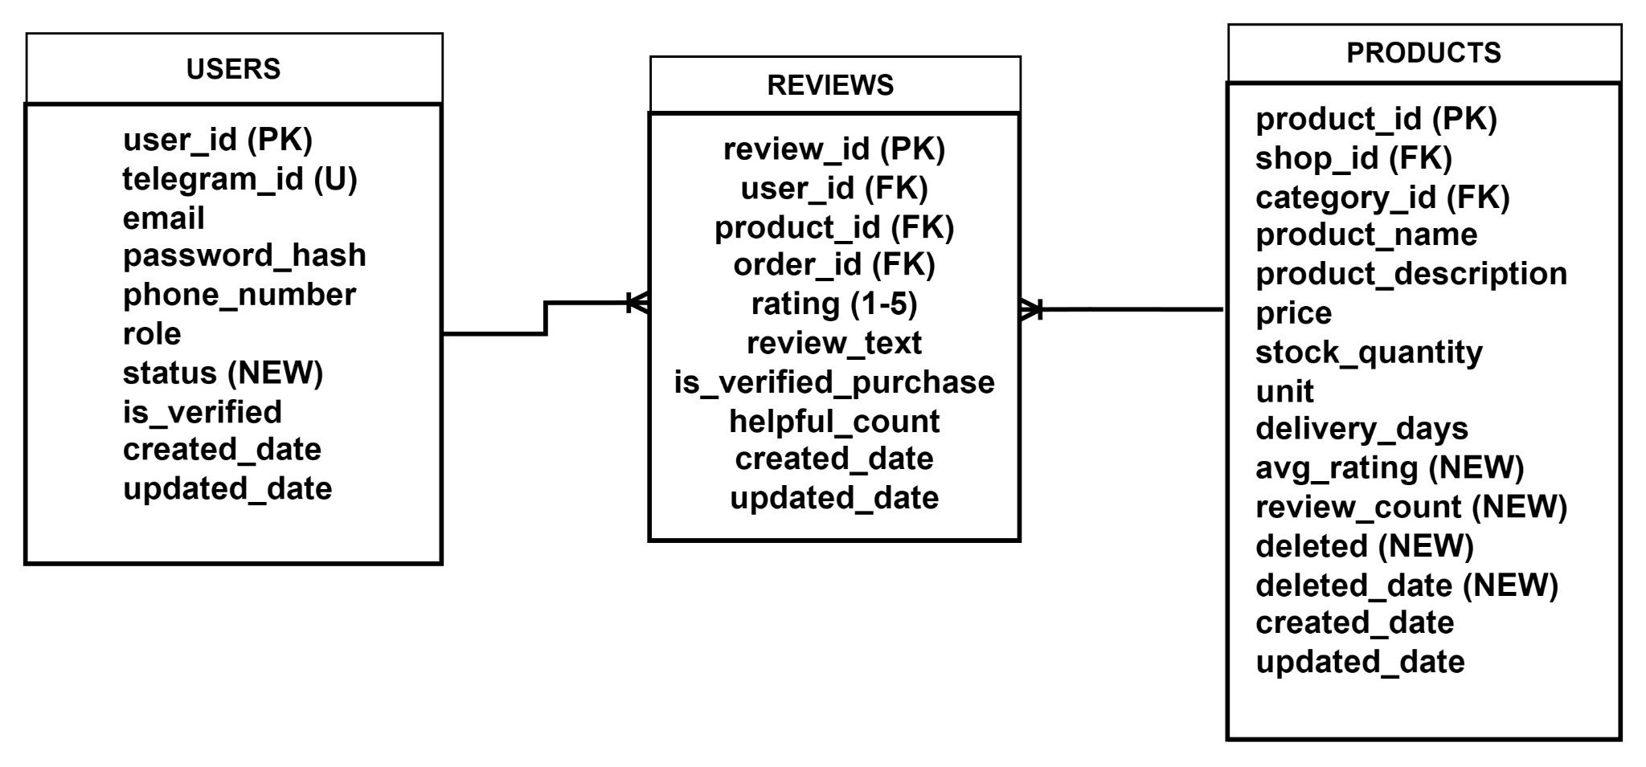
Figure 10: Database Design - Reviews & Verification Relationships
Products ↔ Reviews (1–M) and Users ↔ Reviews (1–M): Customers can review products, and each review is linked to both user and product.

7. Invoices & Support Relationships
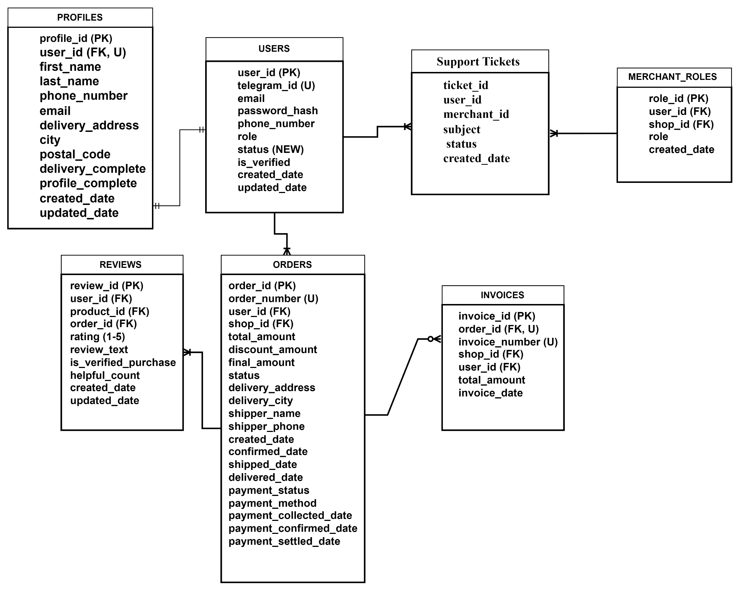
Figure 11: Database Design - Invoices & Support Relationships
Orders ↔ Invoices (1–0..1): An invoice may be generated for an order (optional depending on merchant/admin use).
Orders ↔ Reviews (1–M): Reviews can be linked to orders to support “verified purchase” logic.
Users ↔ Support Tickets (1–M) and Merchants ↔ Support Tickets (1–M): Customers can create support tickets and merchants can respond.
Users ↔ Profiles (1–1): Each user has one profile containing delivery details and personal information.

8. Payment Table Relationships

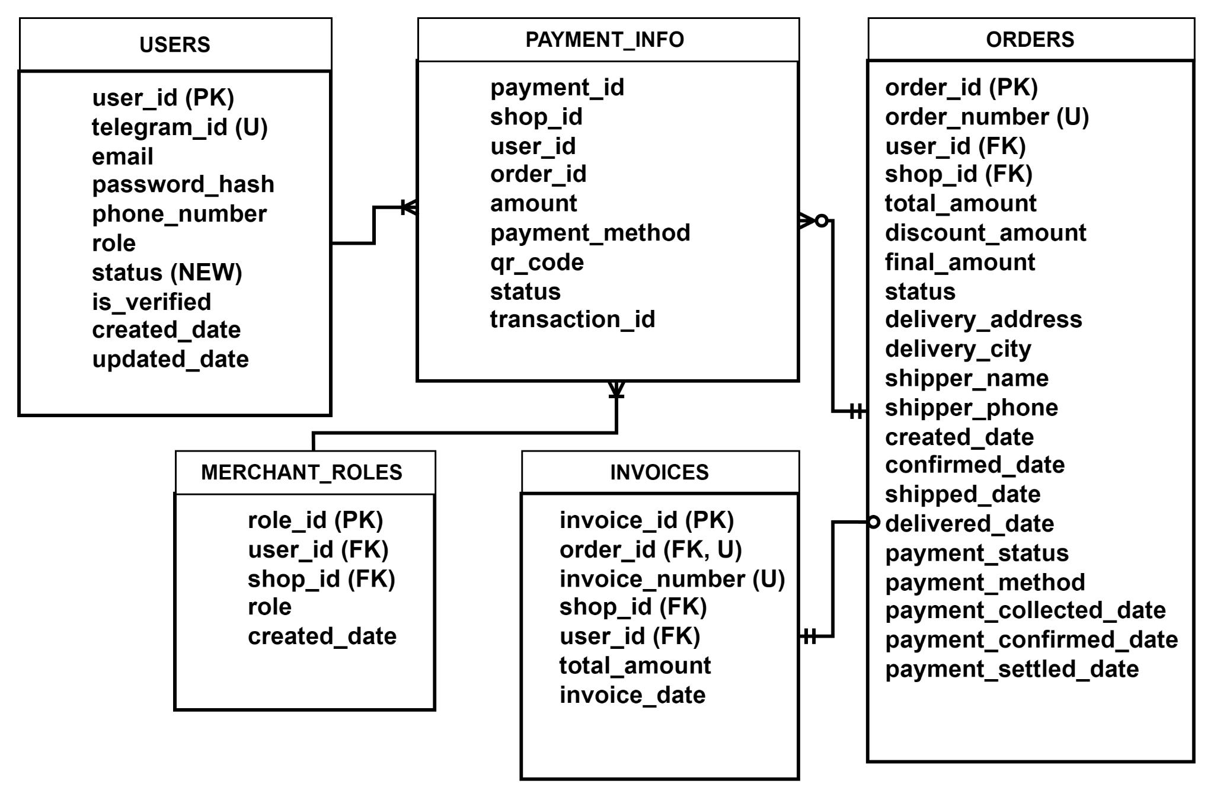
Figure 12: Database Design - Payment Table Relationships
Orders ↔ Payments (1–0..M): An order may have zero or multiple payment records (e.g., COD collection, retry attempts, or partial payments).
Users ↔ Payments (1–M): A user can make multiple payments across different orders.
Merchants ↔ Payments (1–M): A merchant can receive multiple payments for different orders.
Orders ↔ Invoices (1–0..1): An invoice may be generated for an order (optional). (To enforce 0..1, use UNIQUE(order_id) in Invoices.)

Main Tables:
1. Users Table
- user_id - Unique ID for each user
- telegram_id - Telegram's unique user ID
- username - User's username
- email - Email address
- password_hash - Encrypted password
- phone_number - Contact phone
- role - User role (customer, merchant, admin)
- is_verified - Account verification status
- created_date - When account was created
- updated_date - Last update time
2. Profiles Table
- profile_id - Unique ID
- user_id - Link to user
- first_name - User's first name
- last_name - User's last name
- delivery_address - Address for deliveries
- city - City name
- postal_code - Postal code
- delivery_complete - Delivery completion status
- created_date - Profile creation date
- updated_date - Last profile update
3. Merchants Table
- merchant_id - Unique ID for each merchant/shop
- merchant_name - Name of the shop
- shop_description - Description of shop
- category - Shop category (electronics, fashion, food, etc.)
- contact_phone - Shop phone number
- owner_id - ID of shop owner
- status - Shop status (active, inactive)
- created_date - When shop was registered
- updated_date - Last update
4. Products Table
- product_id - Unique ID for each product
- merchant_id - Which merchant owns this product
- category_id - Product category
- product_name - Name of product
- product_description - Details about the product
- price - Cost to customer
- stock_quantity - How many items available
- unit - Unit of measurement
- delivery_days - Expected delivery time
- avg_rating - Average customer rating
- review_count - Number of reviews
- deleted_date - If product is deleted
- created_date - When product was created
- updated_date - Last update
5. Product Images Table
- image_id - Unique ID
- product_id - Link to product
- image_url - Link to product image
- is_primary - If this is the main image
- display_order - Order to display images
- upload_date - When image was uploaded
6. Product Categories Table
- category_id - Unique ID
- category_name - Name of category
- category_description - Description
- created_date - When created
7. Shopping Cart Table
- cart_id - Unique ID
- user_id - Which customer
- shop_id - Which shop
- product_id - Which product
- quantity - How many
- unit_price - Price per item
- discount_percentage - Any discount
- final_price - Final calculated price
- promo_id - If promotion applied
- added_date - When added to cart
8. Orders Table
- order_id - Unique ID for each order
- order_number - Human-readable order number
- merchant_id - Which merchant fulfilled order
- user_id - Which customer placed order
- total_amount - Total price
- discount_amount - Discount applied
- final_amount - Final price after discount
- status - Order status (pending, confirmed, shipped, delivered)
- delivery_address - Where to deliver
- delivery_city - City for delivery
- shipper_name - Delivery person name
- shipper_phone - Delivery person phone
- created_date - When order was placed
- confirmed_date - When merchant confirmed
- shipped_date - When shipped
- delivered_date - When delivered
- payment_status - Payment status
- payment_method - KHQR or Cash on Delivery
- payment_collected_date - When payment received
- payment_confirmed_date - When payment confirmed
- payment_settled_date - When payment settled
9. Order Items Table
- order_item_id - Unique ID
- order_id - Which order
- product_id - Which product
- quantity - How many ordered
- unit_price - Price per item
- discount_percentage - Item discount
- discount_amount - Discount amount
- final_price - Final price for this item
10. Reviews Table
- review_id - Unique ID
- product_id - Which product
- user_id - Which customer
- order_id - Which order
- rating - Star rating (1-5)
- review_text - Written review
- is_verified_purchase - Purchased this product
- helpful_count - Helpful votes
- created_date - When review posted
- updated_date - Last update
11. Invoices Table
- invoice_id - Unique ID
- order_id - Link to order
- invoice_number - Invoice number
- user_id - Customer ID
- shop_id - Shop ID
- total_amount - Total amount
- invoice_date - When created
12. Payments Table
- payment_id - Unique ID
- shop_id - Shop making payment
- user_id - Customer making payment
- order_id - Associated order
- amount - Payment amount
- payment_method - KHQR or Cash on Delivery
- qr_code - QR code for KHQR
- status - Payment status (pending, confirmed, completed)
- transaction_id - Transaction reference
13. Telegram Configs Table (NEW)
- config_id - Unique ID
- shop_id - Shop this config belongs to
- bot_token - Bot API token
- admin_telegram_id - Admin's Telegram ID
- is_active - Is bot active
14. Support Tickets Table
- ticket_id - Unique ID
- user_id - Which customer
- merchant_id - Which merchant
- subject - What the issue is about
- message - Description of problem
- status - Open or closed
- created_date - When created
Relationships:(write with image)
- One user can have one profile
- One merchant can have many products
- One merchant can receive many orders
- One customer can place many orders
- One order can contain many items
- One product can have many reviews
- One shop can have many payment records
Link to database design and use case : https://drive.google.com/file/d/1sy1INWjb-6opCoHsTwd5Bv2ILkV7w-RV/view?usp=sharing

4.3 UI/UX design (User Journey)
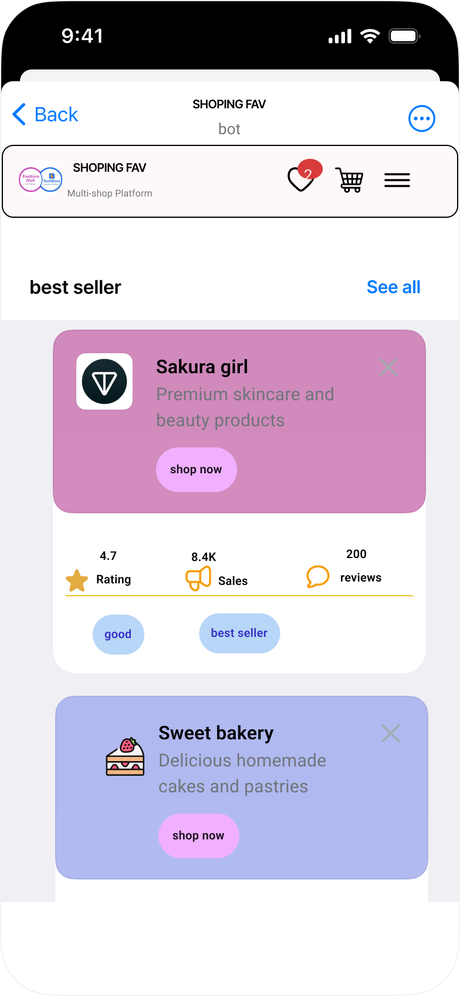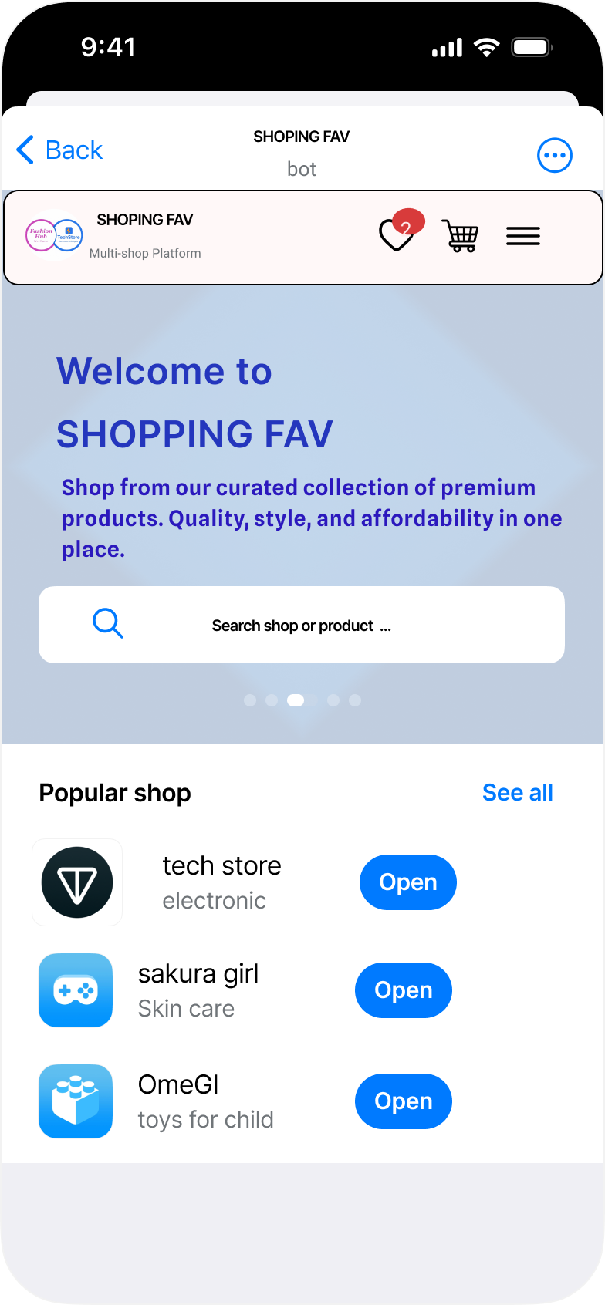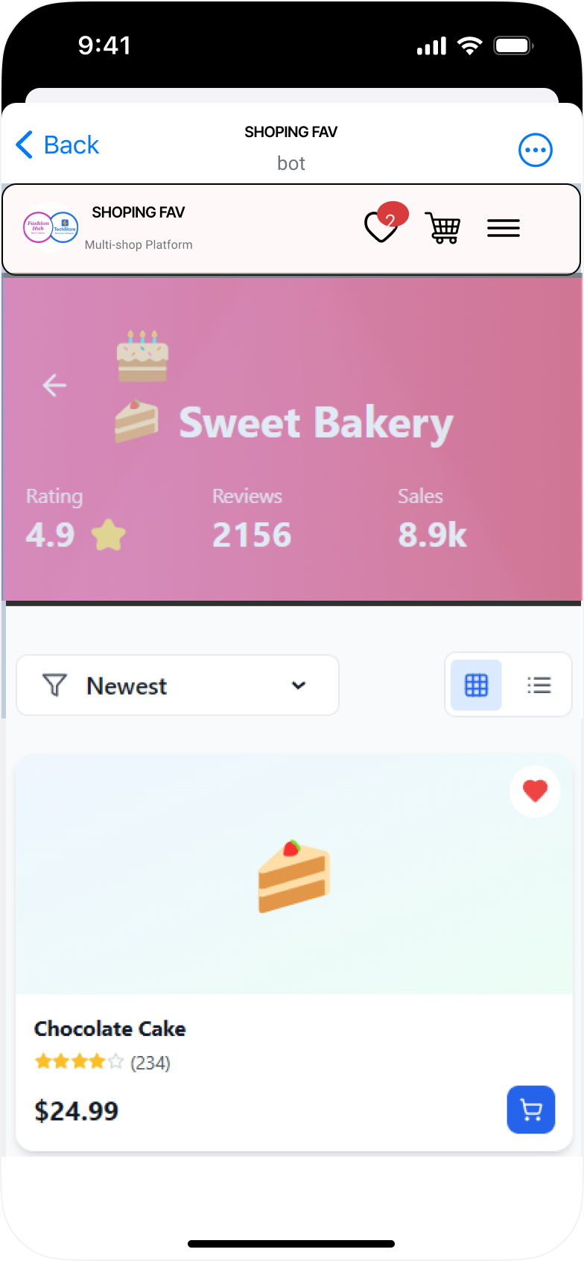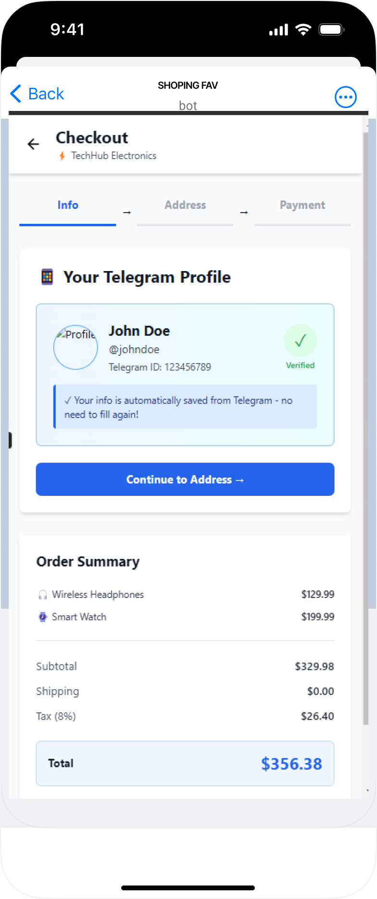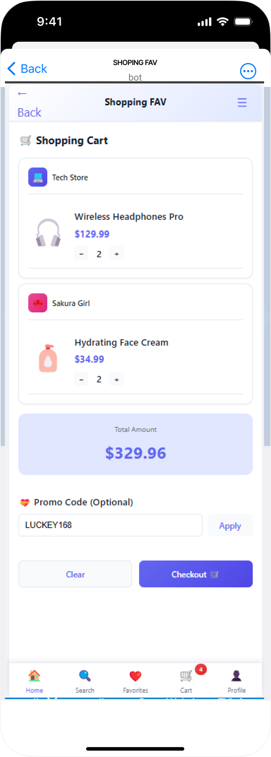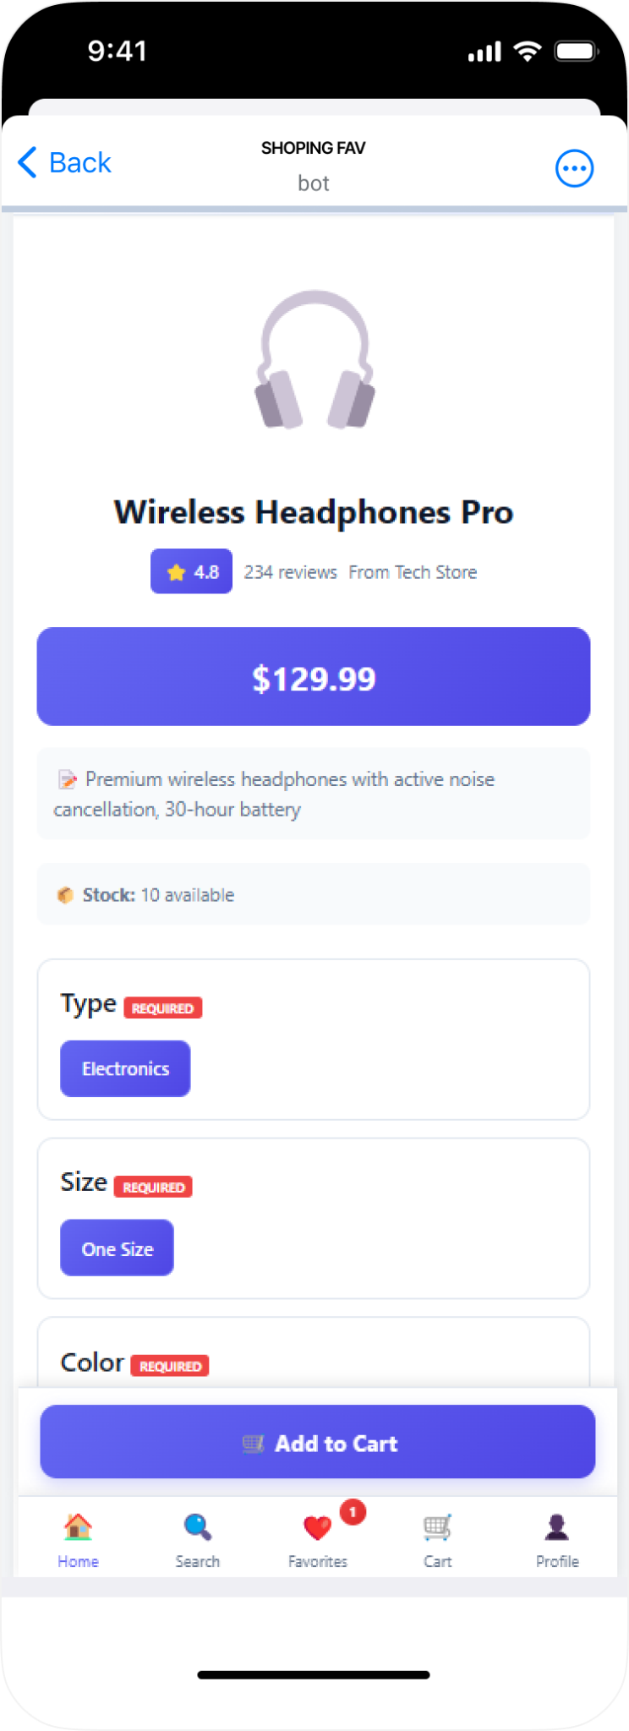 Figure 13: UX/UI Design -User
For Admin /Super Admin Dashboard
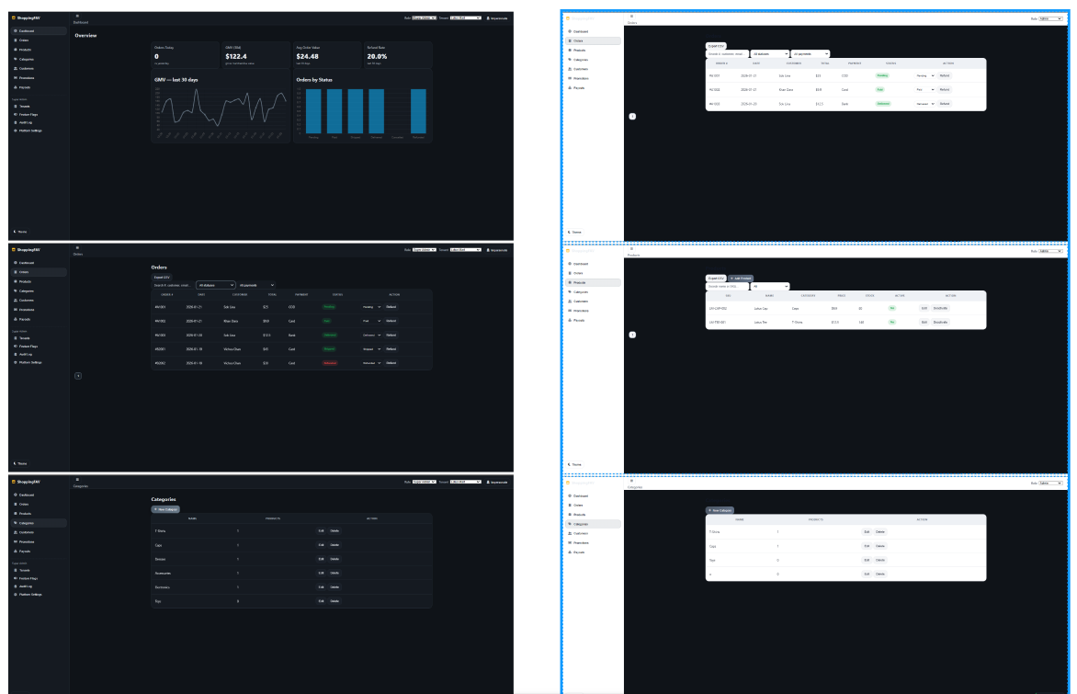
Figure 14: UX/UI Design-Admin
Link
https://www.figma.com/design/u1g1i1U730RR0oKXfrKRx9/EcomerceBot?node-id=11703-13794&t=jTh9ePew0mJLrhwH-1

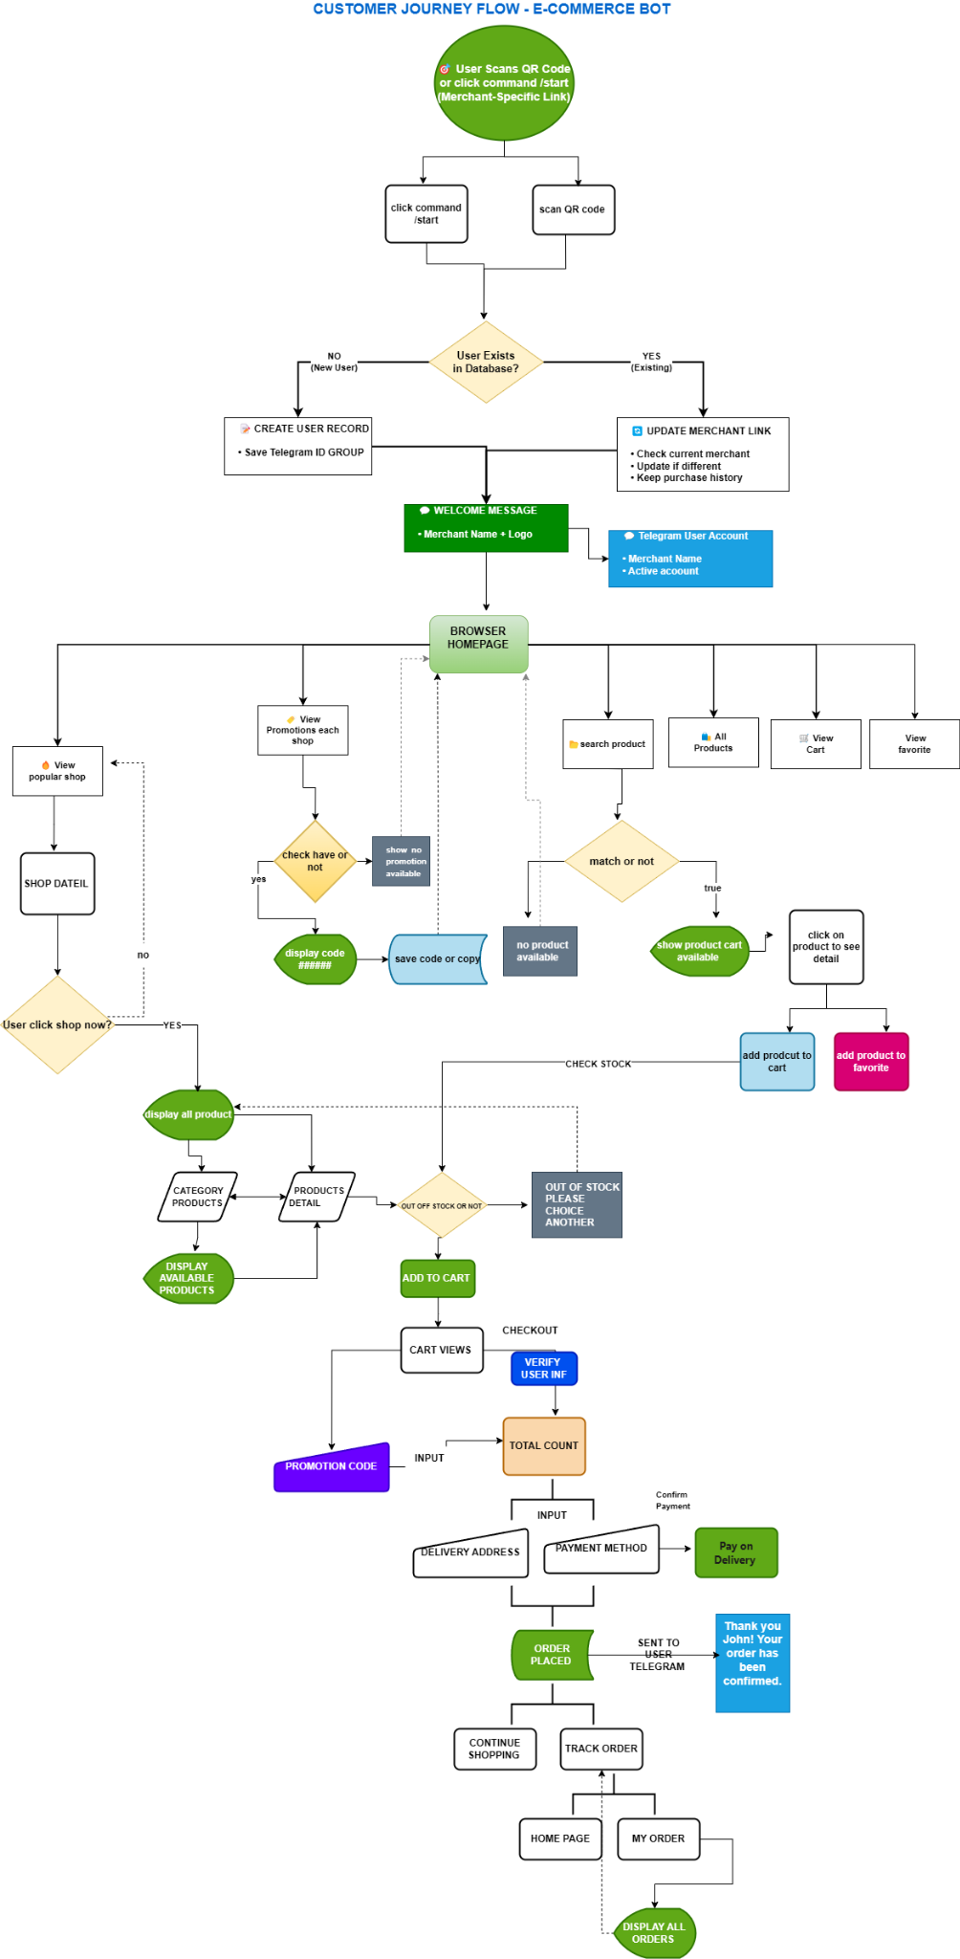
Figure 15: UX/UI Design -Customer-Journey 1-customer-journey.drawio

5. Implementation

5.1 Implementation overview
This project implements a multi-component e-commerce system inside Telegram. The implementation is structured around a single backend service that provides APIs for both user interfaces: (1) a Telegram bot for customers and (2) a web dashboard for merchants and administrators. All data is centralized in a MySQL database to ensure consistent product listings, orders, and user information across the entire system. [7]
The system uses a webhook architecture for Telegram integration. Instead of polling, Telegram pushes updates to the backend through an HTTPS webhook endpoint, enabling near real-time responses and reducing repeated requests to Telegram servers. [8], [9]

5.2 High-Level System Architecture (Frontend ↔ Backend Integration)

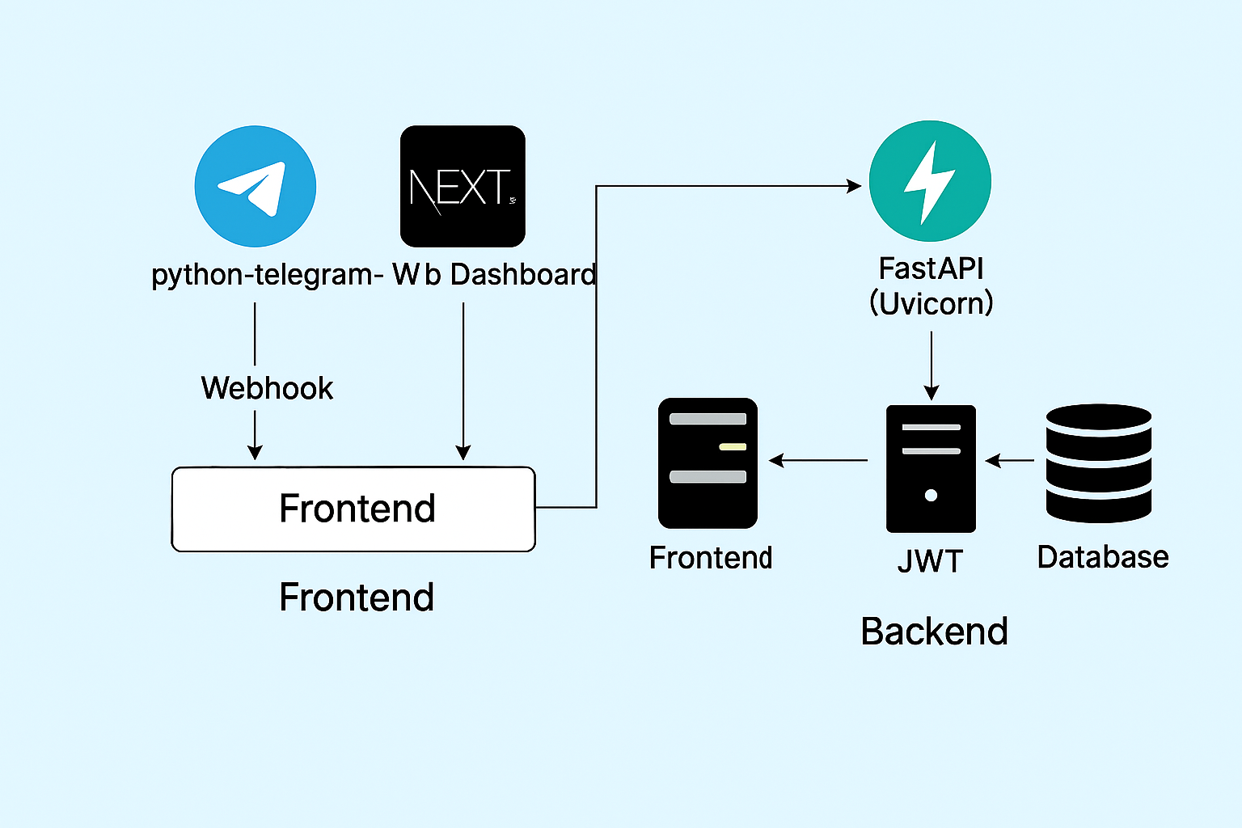
Figure 16: Backend & frontend integration with Technology Stack.
The system consists of the following main components:
- Telegram Bot (Customer Interface)
The Telegram bot is built using the python-telegram-bot library. Customers browse products, add items to cart, checkout, and track order status directly in Telegram. The bot does not store business logic; instead, it forwards actions to the backend API and displays the results to users. [10], [7]
- Web Dashboard (Merchant/Admin Interface) — Next.js
The merchant/admin dashboard is implemented using Next.js. It provides merchant functions such as product management (CRUD), order confirmation, and status updates. Next.js supports environment variables through .env files, and only variables prefixed with NEXT_PUBLIC_ are exposed to the browser. [11]“To connect dashboard sessions with Telegram identity, the bot uses Login URL authorization (login_url) to open the dashboard link with Telegram authorization data, which is validated server-side
- Backend API Server — FastAPI + Uvicorn
The backend is implemented using FastAPI and served using Uvicorn. It provides REST endpoints for authentication, products, cart, and orders. It is responsible for validation, business rules, and database operations.
[7]
- Database — MySQL
MySQL stores system data such as users, merchants, products, carts, and orders. Both Telegram bot and web dashboard access the same data via the backend, ensuring consistency across the platform.

5.3 Backend ↔ Frontend Integration Flow
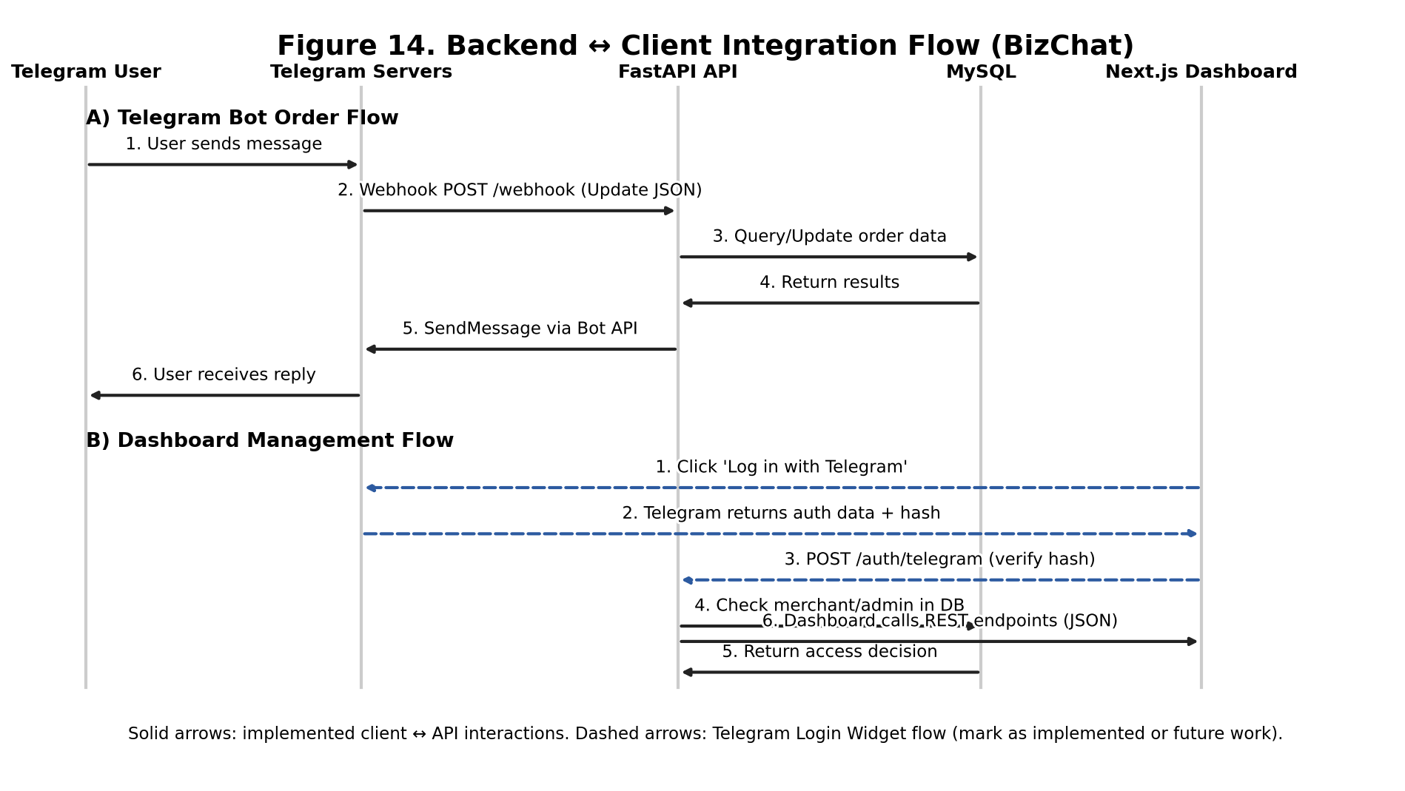Figure 17: Webhook-based System Architecture with Technology Stack.
Figure 17 demonstrates how both clients interact with the FastAPI backend using a standard request–response pattern:
- The Telegram Bot triggers backend actions such as browsing products, placing an order, and checking order status.
- The Next.js dashboard is accessed through a Telegram Login URL button (login_url) that opens the website with Telegram authorization data, and the backend verifies the hash before allowing dashboard access.”
- The backend processes requests and returns JSON responses, which the clients parse and display.
This integration approach ensures that both the bot and dashboard share the same business logic and database, which improves maintainability and prevents inconsistent data handling.

5.4 Authentication & Security (Telegram Login via Bot Login URL)
- Current Implementation: Users are identified in the Telegram bot using Telegram update data (e.g., from.id), which is delivered to the backend through webhook updates. [10], [14]
- Web Login from Telegram (Implemented): The bot provides an inline keyboard button using Login URL authorization (login_url). When the user taps this button, Telegram opens an HTTPS URL and appends the user identity fields and a hash value for authorization. This mechanism is recommended as a replacement for the Telegram Login Widget when users come directly from Telegram. [core.telegram.org], [11]
- Security Verification: The backend verifies the received authorization data by validating the hash using Telegram’s official hashing procedure and checking auth_date to prevent replay. [getorchestra.io]
- Domain Binding: The website domain must be linked to the bot using /setdomain in BotFather to allow secure authorization on that domain.

Detail project feature (table)

Module | Feature | Detailed Description
Authentication System | Telegram Login (Customer) | Customers log in automatically using their Telegram account, identified via telegram_id. No password required. Secure login via Telegram Webhook + Login URL.
 | Merchant Login (Dashboard) | Merchants log in using Telegram Login URL (secure hash verification). No manual password needed. Ensures correct merchant identity.
 | Admin Login | Admins authenticate through dashboard login system (username + password or Telegram login based on your implementation).
 | Session Management | JWT-based authentication for dashboard users. Customers managed via Telegram ID.
Customer (Telegram Bot) | Browse Categories | View all product categories inside Telegram.
 | Browse Products | Browse products by category or merchant.
 | View Product Details | Display images, description, stock, delivery days, and reviews.
 | Add/Remove Cart Items | Add products to cart, update quantity, remove items.
 | Checkout | Input delivery address, choose payment (KHQR / COD).
 | Order Tracking | Check status: Pending → Confirmed → Shipped → Delivered.
 | Review Products | Leave ratings & reviews (verified purchase only).
 | Contact Merchant | Customer can message merchant directly from the bot.
 | View Order History | Displays previous orders with status + totals.
Merchant Dashboard (Next.js) | Merchant Registration | Create merchant account with shop details.
 | Merchant Login (Telegram Authorized) | Merchants access dashboard through Telegram secure login URL.
 | Product Management | Add/edit/delete products + upload multiple images.
 | Order Management | Confirm orders, update statuses, assign shipper details.
 | Dashboard Analytics | Show total sales, order count, top products.
 | Promotions | Create discounts, promo codes, seasonal offers.
 | Customer Support | Respond to customer support tickets.
 | Shop Settings | Edit shop name, phone, category, description.
Admin Dashboard | Admin Login | Full-access login for system administrators.
 | Manage Merchants | Approve, suspend, or delete merchant shops.
 | Manage Categories | Add/remove/update product categories.
 | System Reports | Total users, merchants, orders, payments.
 | Platform Analytics | Daily/weekly/monthly activity insight.
 | System-Wide Promotions | Create promotions for entire platform.
 | Logs & Monitoring | Tracks bot errors, API issues, and system events.
Backend (FastAPI) | Authentication API | JWT login for dashboard, Telegram hash verification.
 | Products API | CRUD for merchants, list/filter for customers.
 | Cart API | Manages cart items, quantity, totals.
 | Orders API | Creates, updates, and retrieves orders.
 | Payments API | Handles KHQR + COD workflows.
 | Reviews API | Stores product reviews and calculates ratings.
 | Webhook Processor | Handles Telegram bot updates in real time.
Database (MySQL) | User Table | Stores customers, merchants, admins.
 | Merchant Table | Shop info + status + owner ID.
 | Telegram Config | Bot tokens + merchant admin Telegram IDs.
 | Products & Images | Products + multiple images per product.
 | Orders & Order Items | Complete e-commerce order structure.
 | Payment Table | KHQR, COD, transaction info.
 | Reviews Table | Ratings, review text, verified purchase.
 | Support Tickets | Communication between customer and merchant.

5.5 Technologies Used
The implementation uses the following technologies:

Backend
- FastAPI (REST API framework) — provides structured endpoints and JSON responses for both clients.
- Uvicorn (ASGI Server) — runs the FastAPI application in production/deployment environments. [11]
- Pydantic — used for request/response validation via schema models (FastAPI relies on typed models for validation).
- MySQL Connector / ORM (depending on your implementation) — handles database operations (CRUD).

Telegram Bot
- python-telegram-bot (or your actual bot library) — receives messages and sends responses through Telegram Bot API.

Frontend (Dashboard)
- Next.js — web dashboard framework for building UI and connecting to backend endpoints.
- Tailwind CSS — styling and responsive layout framework.

Environment Variables (Important Note for Next.js)
Next.js exposes environment variables to the browser only if they are prefixed with NEXT_PUBLIC_. Variables without this prefix are available only on the server side. This is important when configuring items such as a public API base URL used in client-side dashboard requests.

6. Testing
Testing in this project ensures that Mini Ecommerce Telegram Bot works correctly across all components: Telegram bot, backend API, web dashboard, and MySQL database. The testing approach follows a step-by-step workflow (6.1–6.8) and is iterative, meaning after bugs are found, fixes are applied and the system is retested.

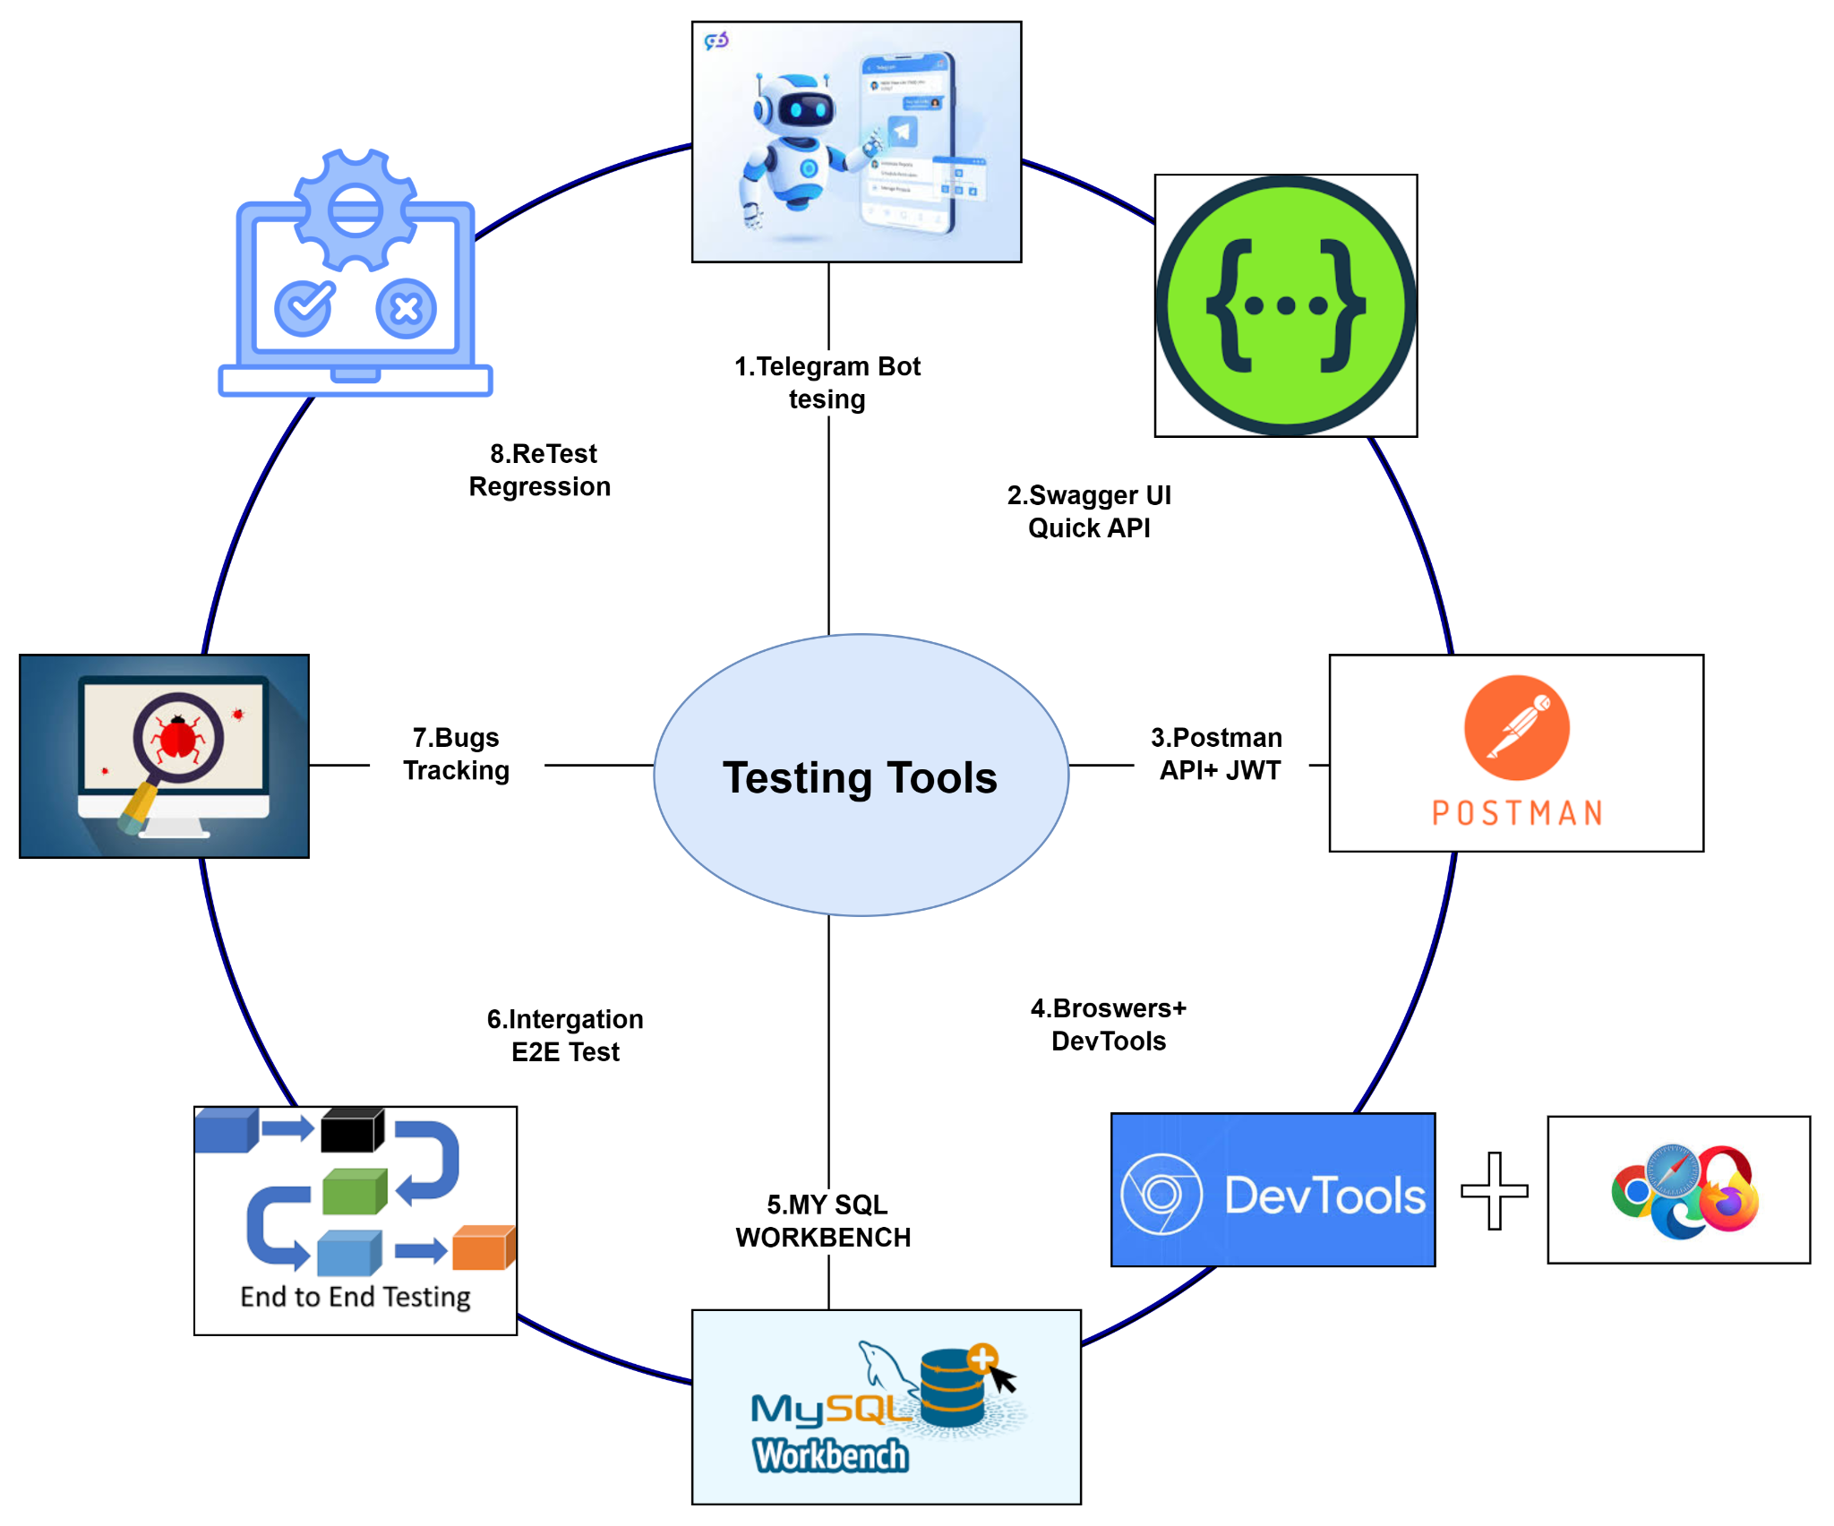
Figure 18: testing tools

6.1 Telegram Bot Testing (App Testing)
The Telegram bot is tested through the Telegram application to confirm that user interactions behave as expected. This includes validating bot entry points such as /start, verifying menu navigation, product browsing flows, cart operations, checkout processes, and customer order tracking. The objective is to ensure that customer-facing features work correctly in real Telegram usage conditions and that bot responses remain consistent and clear.

6.2 API Testing (Swagger UI)
FastAPI’s Swagger documentation interface is used as a rapid method to verify backend endpoints. This step confirms that APIs for authentication, products, cart, and orders respond correctly to valid input. It also supports early detection of schema or validation issues before performing deeper testing through external tools.

6.3 API Testing (Postman + JWT)
Postman is used for more complete backend testing, especially for authentication and authorization. This includes verifying JWT token issuance, access control to protected endpoints, and negative testing such as invalid payloads, expired tokens, and unauthorized access attempts. The goal is to confirm that backend security rules and business logic are enforced correctly.

6.4 Web Dashboard Testing (Next.js Browser Testing)
The merchant/admin dashboard is tested using Next.js in multiple browsers to ensure consistent UI and correct behavior. Testing focuses on:
- page navigation and routing (ensuring links, route transitions, and protected pages work correctly),
- authentication/session behavior in the dashboard,
- correctness of data fetching and UI rendering (especially if SSR/CSR is used),
- responsiveness across screen sizes using browser responsive mode and developer tools.
Because Next.js depends on environment configuration and build behavior, testing also includes verifying that environment variables are correctly applied (e.g., API base URLs), and that dashboard pages behave consistently in both development and production builds.

6.5 Database Verification (MySQL Workbench)
Database verification ensures that records created via both Telegram bot and Next.js dashboard are correctly stored, consistent, and relationally valid. This includes checking users, merchants, products, carts, orders, and order_items. Relationships and constraints are validated to avoid data duplication, missing foreign keys, or inconsistent order totals.

6.6 Integration and End-to-End Testing
Integration testing confirms that the complete workflow operates correctly across components. Key end-to-end verification includes: Telegram bot → backend API → database storage → dashboard display, and the reverse direction where merchants update order status via the dashboard and customers can view updated status via Telegram. This stage is critical because it validates the system as a unified platform rather than isolated modules.

6.7 Bug Tracking and Fixing
Defects found during testing are recorded systematically with reproducible steps, expected results, and actual results. Issues are prioritized based on impact (e.g., login failure or checkout failure is high priority). Fixes are implemented and tracked to ensure progress is measurable and transparent.

6.8 Retesting (Regression Testing)
After fixes, core test cases are repeated to confirm that the defect is resolved and that recent changes did not break existing functionality. Regression testing is essential during iterative development because improvements to one module can unintentionally affect another module.
Testing Tools Used:
Telegram App | Swagger UI | Postman | Chrome/Edge/Firefox |
DevTools | MySQL Workbench | ngrok (Webhook)

7. Future Work
1. Complete Payment System with KHQR
2. Merchant Subscription System 7-Day Free Trial + Paid Subscriptions
3.Automated Bot Messages to Users
4. Improved Reports and Analytics
5. Improved UX/UI
6. Merchant Notification Auto-Messages to Merchant (via Telegram)

8. Conclusion
This project successfully develops a practical e-commerce platform optimized for Cambodia's market reality. By building inside Telegram (where merchants already communicate with customers), instead of creating a separate app, this solution is better suited to Cambodia than expensive alternatives.

9. References
- https://telemetr.io/en/channels/1506456800-lyncambodia
- https://botstore.cc/
- https://teleport.top/
- https://core.telegram.org/bots
- https://nextjs.org/docs
- https://www.grab.com/my/clearer-and-organised-transactions/
- https://fastapi.tiangolo.com/tutorial/security/oauth2-jwt/
- https://fastapi.tiangolo.com/tutorial/cors/
- https://www.geeksforgeeks.org/python/configuring-cors-in-fastapi/
- https://stackoverflow.com/questions/65635346/how-can-i-enable-cors-in-fastapi
- https://nextjs.org/docs/app/getting-started/fetching-data
- https://uvicorn.dev/concepts/asgi/
- https://www.getorchestra.io/guides/fastapi-with-uvicorn-a-comprehensive-tutorial
- https://www.postman.com/davtur19/telegram/request/see7mdn/setwebhook
- blob:https://www.microsoft365.com/6af99e85-0718-4eb9-af02-a05b338cf8e8
- https://bullettrain.co/docs/tunneling
- https://www.compilenrun.com/docs/framework/fastapi/fastapi-documentation/fastapi-swagger-ui/
- https://www.mysql.com/products/workbench/
- https://www.mysql.com/products/workbench/
- https://learn.microsoft.com/en-us/microsoft-edge/devtools/landing/
- blob:https://www.microsoft365.com/53392585-04b7-423e-b88b-a54cb32af779

